

HANDWriting-recognition project report

**Tian Yichen**



August 14, 2019

Contents

ABSTRACT 2

1 INTRODUCTION 3

1.1 Python 3

1.2 Machine Learning 3

1.3 Handwriting Recognition 4

2 IMPLEMENTATION 4

2.1 Training Model 4

2.2 GUI (Graphical User Interface) 5

2.3 Handwriting Board 6

2.4 Run 9

3 CONCLUSION 13

3.1 Strengths 13

3.2 Weaknesses 13

3.3 Personal summary 13

4 REFERENCE 14

ABSTRACT

This project builds a handwriting-recognition project (mnist) based on the Python language, its core techniques are machine learning and Convolutional Neural Networks (CNN). The project is able to recognize the numbers from 0 to 9 written by users.

The main techniques used in the project include: uses Keras to train the model, uses Numpy to calculate the matrix, uses Conv2D to convolute and so on. Also, it uses the wxPython and opencv to provide API interfaces to deal with the problems of the image vision and build the GUI interface in the project.

After testing, the handwriting-recognition project (mnist) can recognize the number efficiently with the accuracy about 99.20%.

**Keywords:** Mnist, Keras, handwriting recognition, CNN, machine learning algorithm;

1 INTRODUCTION

1.1 Python

Python is a computer programming language. An object-oriented, dynamically typed language originally designed to write automated scripts (shells) that are increasingly being used for independent, large-scale project development as versions are continually updated and new language features are added. It is famous for its concise code style and abundant & convenient class libraries. This project is built on the Pycharm platform with the Python 3.6.

1.2 Machine Learning

Machine learning is a multiply cross-disciplinary program that covers probabilistic knowledge, statistical knowledge, approximate theoretical knowledge, and complex algorithm knowledge, etc. It uses computers as tools and is dedicated to real-time simulation of human learning, and the existing content is structured. The main target is to increase efficiency of specific work.

1.3 Handwriting Recognition

Handwriting recognition (or Mnist[1]), make the ordered track information into character code means the words written by users could be recognized by the computer, which is an effective way of the interaction between human and the computer.

Nowadays, with the further development and research of the artificial intelligent, handwriting recognition project has gradually become a representative basic practice project of the machine learning area, since it involves fundamental concepts about the model training, image recognition and CNN algorithm. To use an easy but perfect exemplification, basic handwriting recognition in deep learning and machine learning area could be seemed as the “hello world” in the programming, or so-called the foundation.

2 IMPLEMENTATION

2.1 Training Model

In this part, first I download the training sets from the internet and used the keras algorithm[2], tensorflow and numpy library to learn about the sets and obtain the final model, which are a total of 60,000 samples. The final training result showed that the error rate is 0.80% and the figure is shown below as Fig 1.

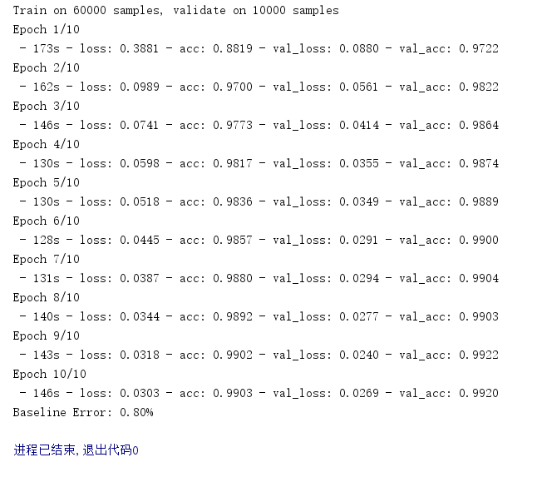

Fig 1 Final result of the training

2.2 GUI (Graphical User Interface)

GUI (Graphical User Interface) provides an interface for human to interact with the machine, which is just like a bridge between human and computer. In this part, I used the tkinter[3] and wxpython library to create a GUI.

Tkinter is a static Tk GUI toolbox interface, which can be used in python to build GUI quickly includes several basic elements like labels, buttons, text fields and so on, and these modules have dozens of characteristics such as dimension, color, font, anchor, relief, bitmap, cursor to adjust them. Label plays an important role in this part, which is used to display the information like words and pictures instead of interacting with the users.

This project includes three buttons namely Generate Pattern, Refresh and Recognize, which represent three different functions as writing the number, show the number and recognize the number. The whole GUI was shown below as Fig 2.

2.3 Handwriting Board

Compared with the traditional handwriting numeral recognition project that uploads a number picture and recognize the number on it, this project enables users to use their mouse and write the number casually (only 0 to 9), which is much more convenient and faster than before. This function needs a handwriting board.

In this project, the handwriting board was achieved based on the opencv2[4], a kind of technique about the image vision. First, I imported the numpy and cv2 from the libraries. Then I set the background color as black, and set the coordinates of the frame to determine the position and size about the handwriting board. Next, cv model enables the possibility of the button events. Both mouse and keyboard press events are created in this project. (The handwriting board was shown as Fig 2, 3 below).

What’s more, I used the pack function to enable the size of GUI could be changed casually with the windows’ size.

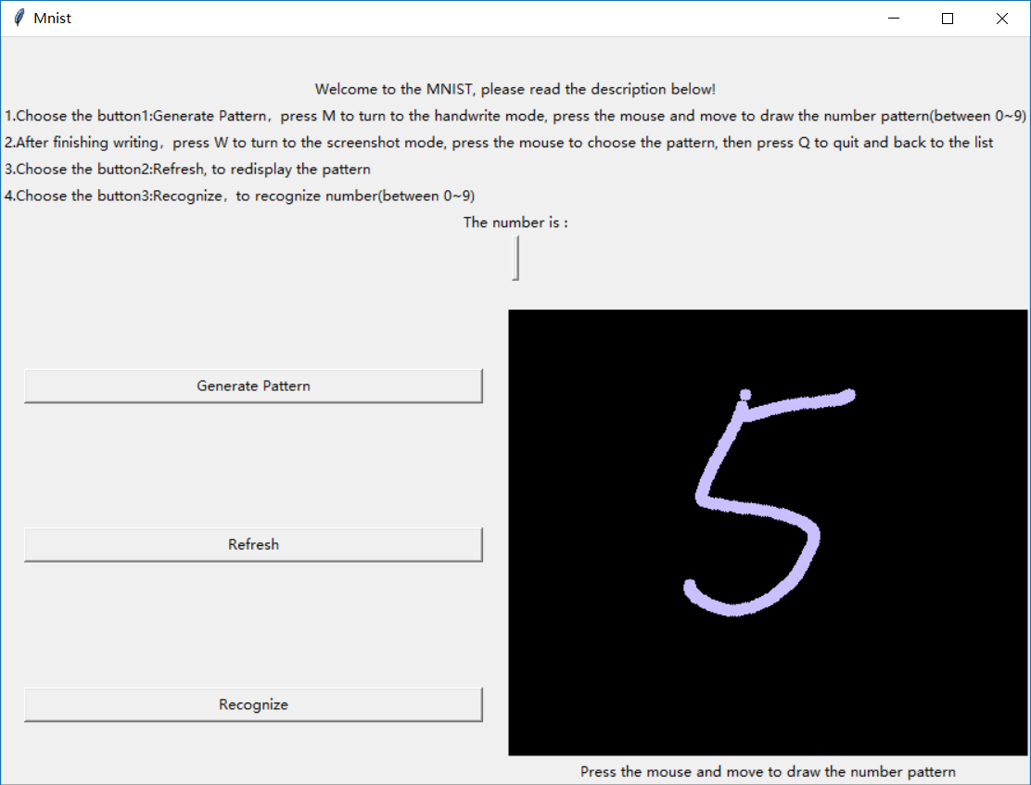

Fig 2 GUI

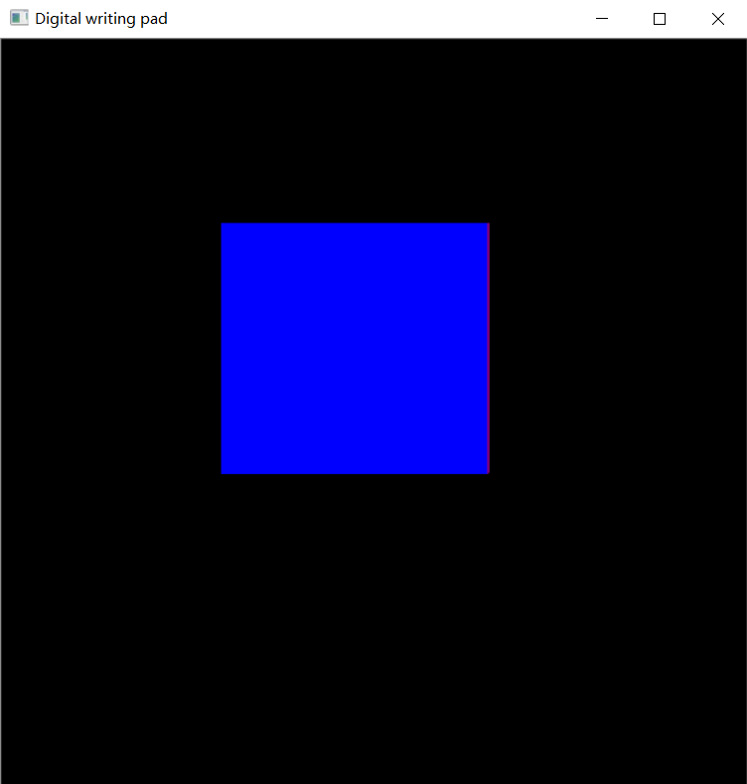

Fig 3 handwriting board

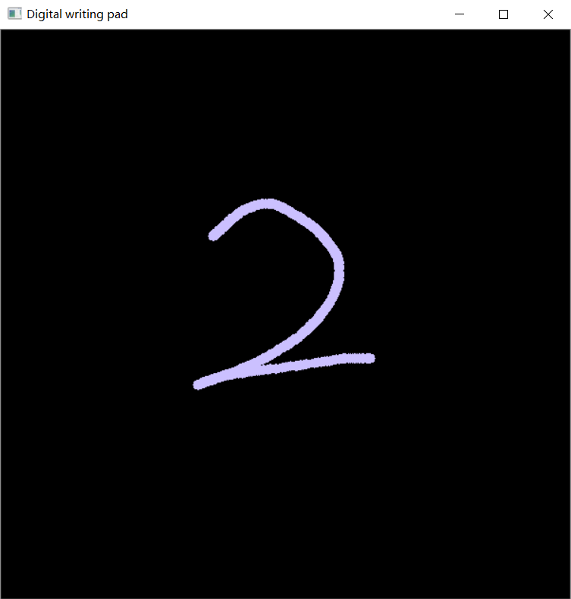

Fig 4 handwriting board

2.4 Run

* Step1: Choose the button1:Generate Pattern (Fig 5)，press M to turn to the handwrite mode (Fig 6), press the mouse and move to draw the number pattern (Fig 7) (between 0~9).

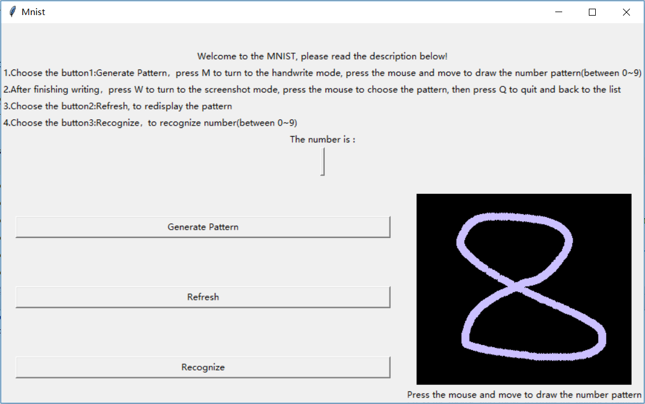

Fig 5 button 1: Generate Pattern

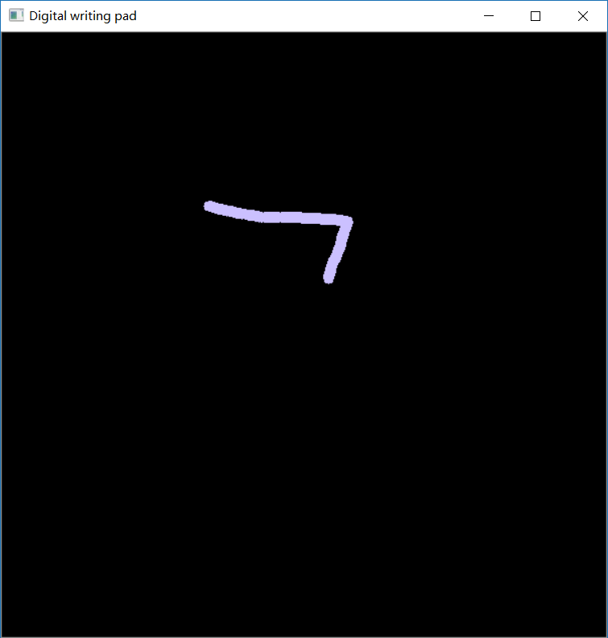

Fig 6 handwriting mode

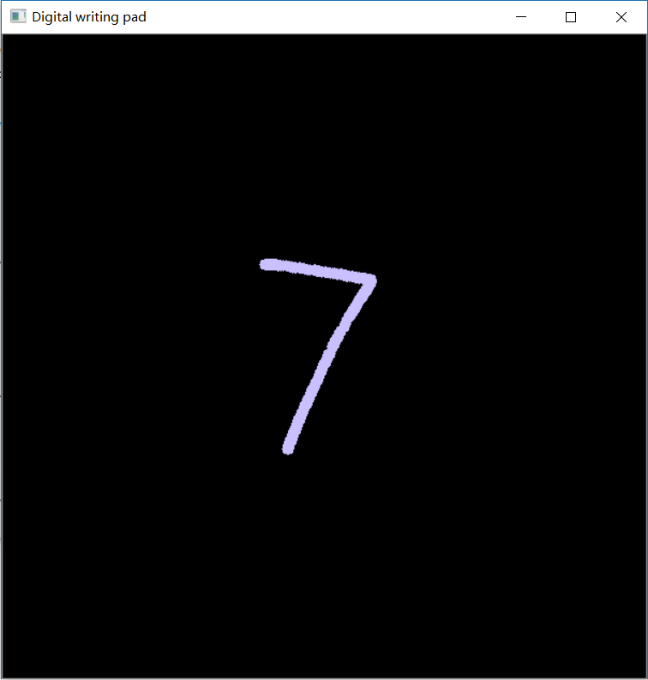

Fig 7 handwriting example

* Step2: After finishing writing，press W to turn to the screenshot mode, press the mouse to choose the pattern (Fig 8), then press Q to quit and back to the list.

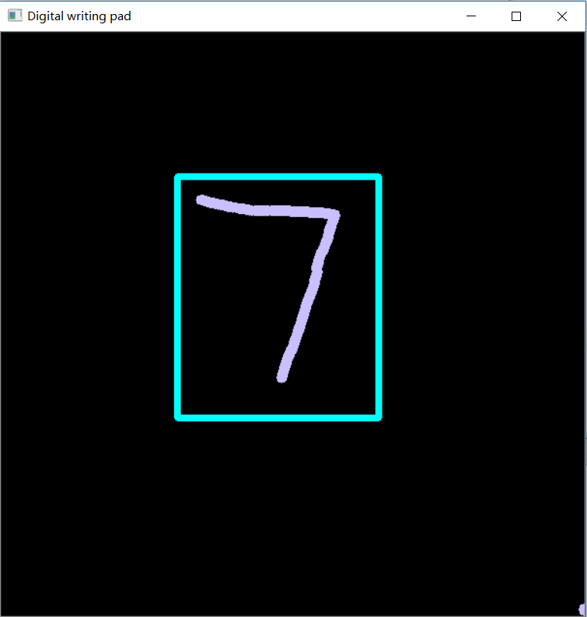

Fig 8 screenshot mode

* Step3: Choose the button2: Refresh, to redisplay the pattern (Fig 9).

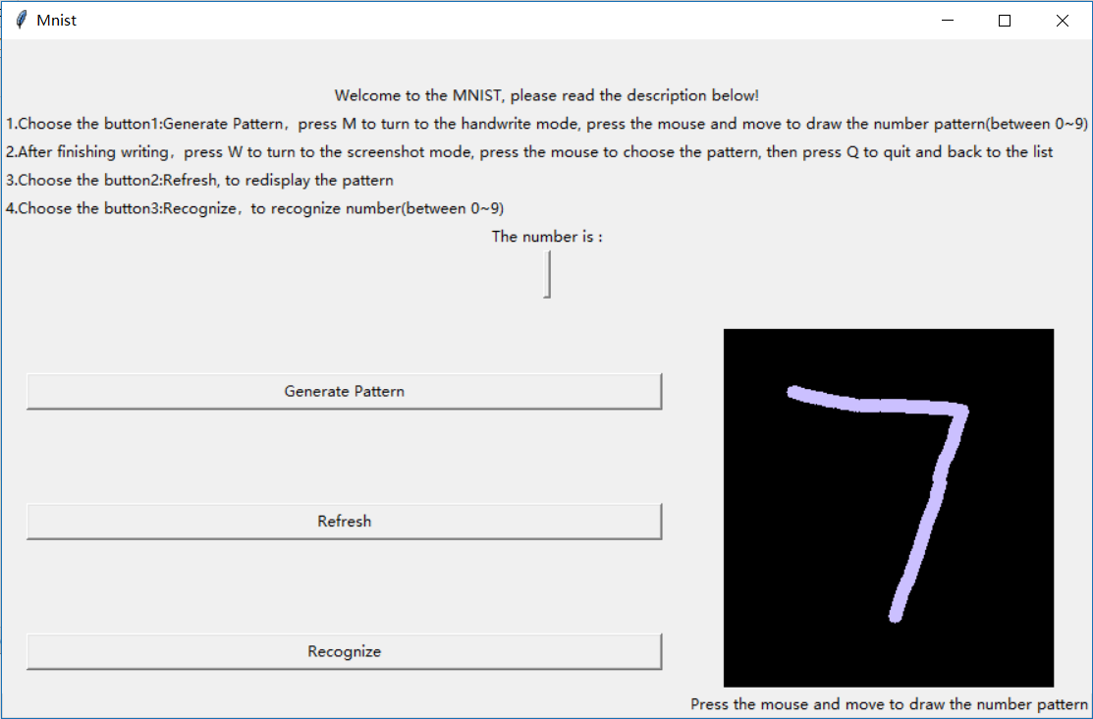

Fig 9 button2: refresh to redisplay the pattern

* Step4: Choose the button3:Recognize，to recognize number (Fig 10) (between 0~9).

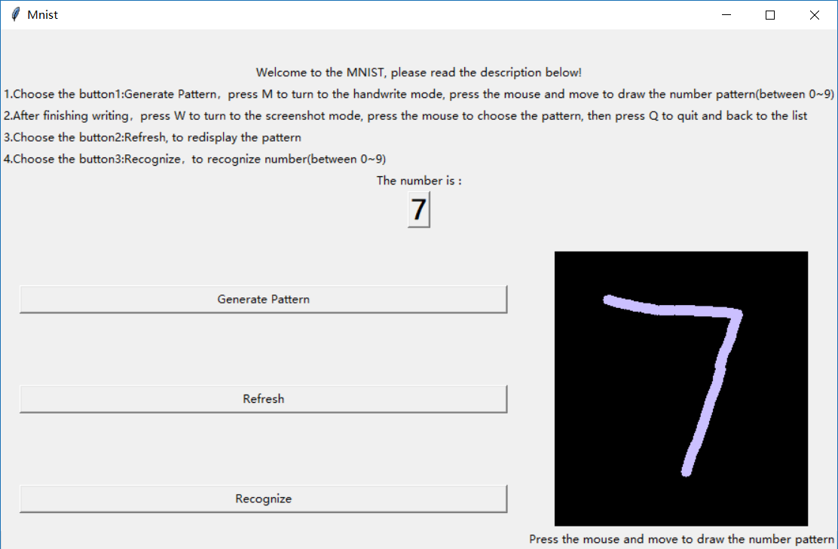

Fig 10 button3: Recognize the pattern

3 CONCLUSION

3.1 Strengths

* Time saving: The use of handwriting board (or handwriting pad) makes it possible for users to recognize the number as soon as they have written on it instead of uploading the pictures.
* Convenient: The project is easy to use, just run it and do with the description.

3.2 Weaknesses

* Range limited: It can only recognize the number between 0 to 9.
* Appearance: The GUI of the project is too simple.

3.3 Personal summary

The project shows the handwriting recognition based on tensorflow and keras could recognize the number at accuracy about 99.20%, which is pretty high and acceptable. And it is the foundation of the interaction between human and the machine, it also promotes the further development in the artificial intelligent and machine learning areas.

During the project, I have learnt lots of knowledge about the big date mining and analysis, and also practice the use of python language as well as Github.

At the same time, the teacher of this project, Zhang Fan has given me lots of help and guidance, he taught us patiently and gave enough time to let me absorb the information and do practice. He encourages students to learn more about the big data after class.

Although the project has several aspects that need to improve, I still feel pleasant and accomplishment when I get the final results, I will keep going and studying in this area.

4 REFERENCE

[1]康明. (2010). 手写体数字识别技术研究. (Doctoral dissertation, 武汉理工大学).

[2]<https://zhuanlan.zhihu.com/p/58826227>

[3] <https://blog.csdn.net/m0_38039437/article/details/80537531>

[4] <https://www.cnblogs.com/cquer-xjtuer-lys/p/10252479.html>